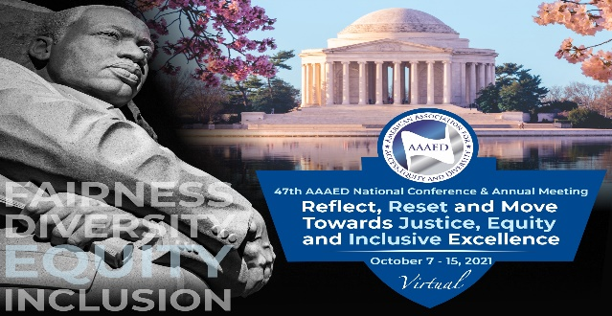
American Association for Access, Equity and Diversity Announces
The 2021 Rosa Parks Award Honoree
Dr. Ruth J. Simmons, President of Prairie View A&M University, will be honored with the Rosa Parks Award for her lifetime of service during the Association’s 47th National Conference and Awards Ceremony on October 15, 2021

For Immediate Release: August 30, 2021
Contact: Shirley J. Wilcher 240-893-9475
execdir@aaaed.org
https://www.aaaed.org/aaaed/Conference.asp

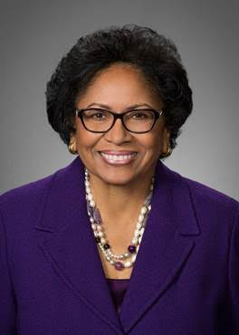
Washington, DC, August 30, 2021 - The American Association for Access, Equity and Diversity (AAAED), an organization of equal opportunity, diversity and affirmative action professionals, announced that it will confer the Rosa Parks Award on Dr. Ruth J. Simmons, President of Prairie View A&M University. “We are humbled to have the opportunity to honor such an outstanding icon of social justice and excellence in education, diversity and equal opportunity,” said Dr. Richard Anthony Baker, president of AAAED.

The awards celebration will be held on Friday, October 15, 2021 during the AAAED’s 47th National Conference and Awards Ceremony (October 7 - 15, 2021). Themed “Reflect, Reset and Move Towards Justice, Equity and Inclusive Excellence,” the ceremony will be held virtually from 2:00 pm – 3:30 pm ET.

Named for the civil rights icon who refused to surrender her seat to a white passenger on a segregated bus and sparked not only the Montgomery Bus Boycott but the ultimate end of racial segregation of public facilities, the Rosa Parks Award recognizes an individual who serves as a role model and leader for others through his or her personal achievements, excellence in a chosen field; commitment to human, civil rights and social issues and contributions to the betterment of society. Previous recipients include Rep. Maxine Waters (2020), Dr. Johnnetta Betsch Cole (2019), Rogsbert Phillips-Reed (2018), and Rep. Sheila Jackson Lee (2016).

Ruth J. Simmons serves as President of Prairie View A&M University. She was President of Brown University from 2001-2012. Under her leadership, Brown made significant strides in improving its standing as one of the world’s finest research universities.

A French professor before entering university administration, President Simmons held an appointment as a Professor of Comparative Literature and Africana Studies at Brown. After completing her Ph.D. in Romance Languages and Literatures at Harvard, she served in various faculty and administrative roles at the University of Southern California, Princeton University, and Spelman College before becoming president of Smith College, the largest women’s college in the United States. At Smith, she launched a number of important academic initiatives, including an engineering program, the first at an American women’s college.
Simmons is the recipient of many honors, including a Fulbright Fellowship to France, the 2001 President’s Award from the United Negro College Fund, the 2002 Fulbright Lifetime Achievement Medal, the 2004 Eleanor Roosevelt Val-Kill Medal, the Foreign Policy Association Medal, the Ellis Island Medal of Honor, and the Centennial Medal from Harvard University. Simmons is a member of the National Academy of Arts and Sciences, the American Philosophical Society, and the Council on Foreign Relations, and serves on the boards of the Houston Museum of Fine Arts, the Smithsonian National Museum of African American History and Culture, and the Holdsworth Center. She also serves on the Board of Directors of Square. Awarded numerous honorary degrees, she received the Brown Faculty’s highest honor: the Susan Colver Rosenberger Medal in 2011. In 2012, she was named a ‘chevalier’ of the French Legion of Honor.

The AAAED 47th National Conference and Awards Ceremony is open to the press. For more information or to register for the Conference, October 7 – 15, 2021, go to: https://www.aaaed.org/aaaed/Conference_Agenda1.asp.

To sponsor the awards ceremony, click here: https://www.aaaed.org/aaaed/Sponsorship.asp

To purchase a ticket or if you are a member of the news media, click here: https://web.cvent.com/event/b3824076-d018-4321-81ee-a0acb1498131/summary

For more information about the Awards Ceremony, contact Rosemary Cox, at rcox@dciconsult.com.

Founded in 1974 as the American Association for Affirmative Action (AAAA), AAAED is a national not-for-profit association of professionals working in the areas of equal opportunity, compliance and diversity. AAAED has 47 years of leadership in providing professional training to members, enabling them to be more successful and productive in their careers. It also promotes understanding and advocacy of affirmative action and other equal opportunity laws to enhance the tenets of access, inclusion and equality in employment, economic and educational opportunities. AAAED is the longest-serving organization for the Equal Opportunity Profession. Its tagline is “Advocate. Educate. Activate.”

###
American Association for Access, Equity and Diversity
1701 Pennsylvania Avenue, NW, Suite 200 * Washington, D.C. 20006
202-349-9855 * 866-562-2233 * Fax: 202-355-1399 *
www.aaaed.org

