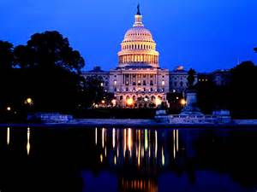

AAAED 47TH NATIONAL
CONFERENCE AND ANNUAL MEETING
VIRTUAL
“Reflect, Reset and Move Towards Justice, Equity and Inclusive Excellence”
CALL FOR PROPOSALS

The American Association for Access, Equity and Diversity (AAAED) is seeking presenters to share their expertise, passion and commitment to promoting diversity and affirmative action with a national audience during our 2021 National Conference and Annual Meeting Virtual on October 11-15, 2021. Our theme for the Conference is Reflect, Reset and Move Towards Justice, Equity and Inclusive Excellence. We are also acknowledging the 60th anniversary of President John F. Kennedy’s Executive Order 10925 establishing affirmative action and nondiscrimination in federal contracts.
AAAED, formerly the American Association for Affirmative Action (AAAA), is a national, not-for-profit association of professionals working in areas of equal opportunity, compliance and diversity. AAAED has 47 years of leadership in providing professional training to members by equipping them to be more successful and productive in their careers. It also promotes understanding and advocacy of affirmative action and other equal opportunity and related compliance laws and regulations to enhance the diversity tenets of access, inclusion and equality in employment, economic, and educational opportunities. Our tag line is: “Advocate. Educate. Activate.”
We are seeking presentations that promote creative innovative strategies and cutting-edge research to enhance equity and diversity in Higher Education, Government, and the Private Sector. Our professional development offerings are intended to help individuals who possess novice, intermediate, or expert level knowledge and skills in their jobs and who are seeking information to stay competitive and relevant in the profession. Our curriculum and workshop options support an adult learner model of instruction that:
- Creates a comfortable and respectful learning environment,
- Emphasizes the trainings’ applicability to address participants’ concerns, needs, interests and career aspirations,
- Utilizes a variety of training methods to vary the presentation of information and help participants understand, and hone knowledge and skills,
- Keeps participants actively engaged, and
- Encourages participants to share ideas and information drawing from their experiences.
We are providing the following presenter workshop formats: Masterclasses, Express Talks, Preconference workshops or “Deeper Dives” (workshops), as well as the standard format workshops offered during the conference. When applying to serve as a presenter, please indicate which format(s) you would prefer to use.
Presentation Formats:
Masterclasses. Masterclass presenters are, as the title suggests, masters in their fields. They will present sharing their unique experiences on a subject by covering not only the substance of a particular issue or challenge, and the application of the law or policy, but also by presenting solutions based on the presenter’s years of experience. Masterclasses are three hours in duration and are offered during the preconference workshop segment or are strategically placed throughout the conference.
Express Talks. Express Talks provide “just the facts,” or the essential aspects of a particular issue or challenge, within 20 minutes. The focus is on practical tips to achieve the desired EEO or Diversity result. Presenters should make themselves available for follow up questions, where possible.
Preconference workshops (“Deeper Dives”). Preconference workshops are intended to be a comprehensive overview of the subject matter, ranging from developing and implementing an affirmative action program to designing and executing a Climate Survey. The time allotment for this presentation is three hours, including time for questions and answers. Presentations should help conference attendees apply theory into practice.
Conference workshops. The time allotment for Conference workshops can range from 60 to 90 minutes and covers a range of topics from legal developments under Title IX, to reasonable accommodations in the transportation industry or barrier analysis in the federal sector.
We are seeking presentations that promote creative, innovative strategies to enhance equity and diversity in Higher Education, Government, and the Private Sector. Ideally, presentations should help conference attendees apply theory into practice. The presentation formats and suggested topics are detailed on the following pages.
There are tremendous benefits to those who make presentations at our conference, including:
- National recognition
- Opportunities to learn and share experiences with others
- Networking
- Professional development
- Registration and exhibition rate discount
For more information about AAAED, please contact us at:

AAAED CONFERENCE 2021
1701 Pennsylvania Avenue, NW Suite 200 | Washington, D.C. 20006 | (202) 349-9855
www.aaaed.org
Program2021@aaaed.org
info@aaaed.org

Please submit your proposal electronically by Friday, March 19, 2021 to the Conference Program Committee: Program2021@aaaed.org

PRESENTATION PROPOSAL REQUIREMENTS
Please review the list of suggested topics prior to submitting proposals. Proposals must show that the presenter understands the mission, vision and conference theme of AAAED.

Proposals should include the following information:
- Indicate the following:
  - Masterclass
  - Express Talks
  - Pre-Conference (“Deeper Dive”)
  - Conference Workshop
  - All submissions should indicate if the proposed presentations are targeted to basic/entry level, intermediate and/or advanced professionals.
  - Conference Track. Please indicate the track for which your presentation applies
        - Compliance
          - EEOC (Private Sector, Federal EEO)
          - OFCCP: Non-construction (supply and service) and construction
          - OCR: Title IX, Title VI and Sec. 504
          - Department of Transportation - FTA Circular FTA C 4704.1A
          - Department of Transportation – DBE Program Compliance
          - Wage Hour
          - National Labor Relations Board
          - Immigration, I-9, E-Verify
          - OSHA
          - Other agencies with EEO compliance requirements
        - All Diversity/Inclusion topics and best practices are welcome
        - Academia
        - Private Industry
        - IT
        - Government (Federal, state or local)
        - Other

Your submission should include:

- Cover page with session title and presenter’s name(s).
- The name, title, organization, complete address, telephone number, fax and email address for each presenter.
- An abstract: up to a one (1) page description of the presentation.
- Provide an outline of your presentation.
- A brief resume or biography of each presenter. Please state whether each presenter is a member of AAAED. If you have presented at a previous AAAED or AAAA National or Regional conference, please indicate the event, year, presentation topic and feedback from such presentations.

Multiple proposals from one presenter(s) are welcome; however, our selection process will limit number of presentations any individual can make to ensure opportunities are made available to a diverse group of presenters. Proposals will be selected based upon relevancy to the conference theme and practice of equal employment (or educational) opportunity, affirmative action and diversity; timeliness of the topic; creativity of approach; and demonstration of expertise. In order to provide a wide range of information to the contractor community, our Program Committee will not select presentations that are scheduled to be made at other similar conferences.

You will be notified if you are a semi-finalist in the selection process. The Review Committee will then contact you to schedule an interview. If selected, the information and materials you provide may be used for marketing and conference publicity, as well as possible resale by AAAED to non-conference attendees. All virtual presentations will be recorded and may be made available to conference registrants for later viewing. All selected presenters must be prepared to provide a copy of their materials by the established date in the notification communication, as well as a picture and current biography for publicity and the conference program book. Selected presenters will be contacted and provided with presenter expectations, curriculum objectives, and additional information. Preference will be given to active AAAED members, PDTI participants and graduates of AAAED certificate programs. To join AAAED, click here: https://www.aaaed.org/aaaed/Join_Us.asp

All submissions must be typewritten and complete to be considered.

Thank you and good luck!

PRESENTATION IDEAS
AAAED welcomes the submission of presentation proposals that:
- Reveal innovative content,
- Elicit discussion, and engage the audience,
- Are relevant and appropriate for conference attendees,
- Are respectful of the many different structures, organization, jurisdiction,
- governance, practices and policies of the participants represented at the
- conference,
- Deliver best practices using modes of instruction to engage various types of audiences such as entry level, mid-level, and executive professionals, and
- Demonstrate current evidence-based knowledge supported by research and/or laws, regulations and guidelines.

Presentations will range from twenty minutes (Express Talks), one hour and fifteen minutes (Conference workshops) to three hours (Masterclass and Deeper Dives) including time for questions and answers. We want to hear from professionals in the public and private sectors and federal/state/local government as well as from educational institutions, groups, organizations and members with expertise in the challenges facing diversity and affirmative action professionals.

Below are examples of topics to consider. This list of topics is not all-inclusive however, and we encourage the submission of proposals regarding other topics. Note that in 2021, AAAED is also acknowledging the 60th Anniversary of Executive Order 10925 signed by President John F. Kennedy. This was the first order specifically requiring affirmative action in federal contracts. Some presenters may wish to focus on this topic. Secondly, as the current President is focusing, in part, on Advancing Racial Equity, presenters may wish to offer strategies to achieve equity in government, the private sector or higher education.

Presentation Ideas Are Encouraged, but Not Limited to, Any of The Following Areas:

Compliance:

- AAP 101 for Business and University
- ADAAA
- Availability, Census, Job Groups
- Communication/Training/Education
- Compensation related
- Complaint Investigations
- Contractor Compliance Best Practices Roundtable
- COVID -19 and EEO Compliance (ADA, Title VII, EO 11246, FMLA and other laws)
- Disability (ADA, Sec. 503 and Sec. 504)
- Disposition Codes
- EEOC Outcomes and Lessons Learned
- Evaluating § 503/VEVRAA Outreach
- Impact of Selection Decisions (Testing, Hiring, Compensation, Promotion, Termination, Performance Management, etc.)
- Innovative DE Supportive Services Programs
- Intersection Between ADAAA, Section 503 and FMLA
- Legal Updates
- Managing EEO and affirmative action in state and local government
- Managing EEO and diversity in the Federal Sector
- Moving Beyond Compliance
- Non-Construction/Construction Contractor Compliance
- OFCCP Audit Outcomes and Lessons Learned
- Pregnancy Discrimination
- Recordkeeping
- Recruitment, Retention and the Selection Process
- Respectful Workplaces
- State and Federal EEO/Affirmative Action Laws
- Surviving an OFCCP or FTA Audit
- Section 503 of the Rehabilitation Act of 1973, as amended
- Section 504 of the Rehabilitation Act of 1973, as amended
- Title VI of the Civil Rights Act of 1964, as amended
- Title VII of the Civil Rights Act of 1964, as amended
- Understanding Federal Transportation Authority FTA Circular C 4704.1A
- Investigation Basics
- Update on Title IX Law and Policy including Harassment Regulatory Changes
- Vietnam Era Veterans Readjustment Assistance Act as amended
- Legislative and Regulatory Updates: Changes in New Leadership/Changes in Policy

Academia:

- Academic Innovated Best Practices Roundtable
- Aligning Compliance to the Academic Mission
- Balance between Government Ethics and Academic Freedom
- Campus and Classroom Climate and Climate Surveys
- Changing the Landscape of Higher Education
- Delivering Results and Making Changes
- D & I Best Practices to include faculty recruitment retention
- Faculty Recruitment and Retention – Compliance and innovations
- Federal EEO Barrier Analysis
- Hate Speech vs. Free Speech
- How to Determine if Classroom Climate is Productive
- How to Manage Classroom Climate
- Implicit Bias and Microaggressions on a College Campus: Intent, Impact, and Reduction
- Incivility on Campus, how do you handle it?
- Incivility vs. Free Speech
- Managing Campus Harassment Issues
- Managing affirmative action and diversity in states where affirmative action is prohibited:(e.g., California, Arizona, Nebraska, Washington State and Michigan)
- Social Justice and Diversity in Higher Education
- Title IX and Title VI Compliance to include investigations
- Title IX Best Practices
- Using Compliance to Elevate Institutional Effectiveness
- What Factors Affect Campus and Classroom Climate?
- Linking DEI & Student Success

Diversity/Inclusion:

- AAP and Diversity: Playing Nice in the Sandbox
- Accommodations in the Workplace
- Attracting, Hiring and Retaining Diverse Talent
- Breaking Down Silos in the Workplace
- Change Management – Leading Effective D&I Efforts
- Creating an Impactful Culture for People with Disabilities
- Disability Etiquette
- Diversity Metrics & Measurements
- Getting your C Suite to Support your Mission
- Incivility in the Workplace, How to Handle it?
- LGBTQ Questions/Issues in the Workplace
- Moving Beyond Diversity towards Equity and Inclusion
- Organizational Surveys
- Recruiting and Retaining Individuals with Disabilities
- Utilizing Untapped Talent to Reach Diversity Goals
- Veteran Recruiting and Retention
- Veterans Questions/Issues in the Workplace
- Making the Business Case for Diversity, Equity and Inclusion
- Diversity Metrics and Risk Management: Incorporating the Law of EEO
- Measuring the Efficacy of Diversity and Inclusion Programs
- Inclusive Excellence: What is it? How Does it Help to Achieve Diversity, Equity and Inclusion?
- Microaggressions/Microbullying

Other:

- How to Determine if Organizational Climate is Productive
- How to Manage Organizational Climate
- How to Overcome the Lack of Females, People of Color in the IT Industry
- Intersection between Affirmative Action and Diversity
- Leadership Development
- Managing Implicit Bias and Unconscious Bias in the Workplace
- Managing Workplace Harassment Issue
- Mentor/Protégé Programs
- Designing Organizational Climate Surveys
- Project Labor Agreements
- Recruitment and Retention in the IT Industry
- Succession Planning
- The Neuroscience of Civil Rights: Equity and Contract Compliance (Defining the Challenges)
- The Neuroscience of Civil Rights: Equity, and Contract Compliance (Solutions)
- What Factors Affect Organizational Climate?

- Workplace and Campus Safety
- Employee Resource Groups
- Emotional Intelligence
- Artificial Intelligence

- Artificial Intelligence and its Impact on Individuals with Disabilities
- Employee engagement
- Analytics
- Digital Transformation
- HR as a Strategic Business Partner

Please submit your proposal electronically by Friday, March 19, 2021 to the Program Committee and indicate the tracks for which your presentation is submitted, i.e., Compliance, Academic, Diversity/Inclusion and/or Other:
AAAED Conference 2021 Program Committee
Program2021@aaaed.org

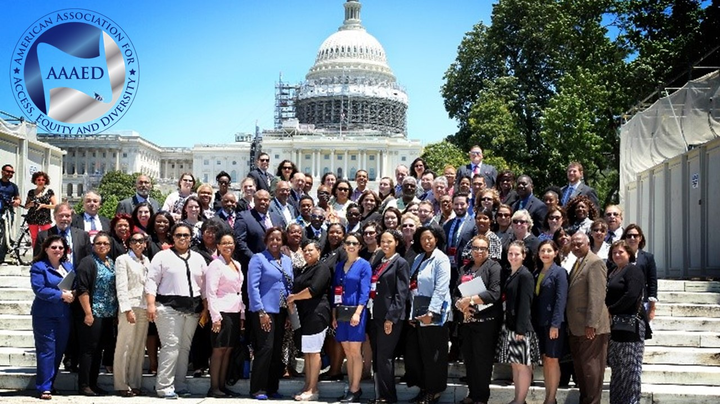

1701 Pennsylvania Avenue, NW • Suite 200 • Washington, DC 20006 • Phone: 866-562-2233
202-349-9855, • Fax: 202-355-1399 • execdir@aaaed.org • www.aaaed.org

