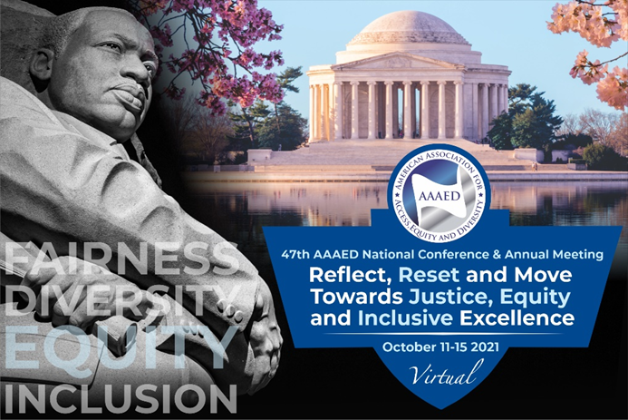

AAAED 47th NATIONAL CONFERENCE AWARDS NOMINATION FORM

Nomination Deadline: May 14, 2021

Each year AAAED gathers at our National Conference and Annual Meeting to celebrate the lives and accomplishments of those who have made an impact in our industry. We invite you to recommend individuals who have made significant contributions in the areas of equal employment opportunity, diversity, equity and inclusion, community service advocating for disability rights and leadership. Nominations can be for individuals, groups, organizations or companies. Thank you for your support of nominees who share AAAED’s commitment to access, equity and diversity.
Award Category (check all that are applicable):

Arthur A. Fletcher Lifetime Achievement Award: presented to an individual with a lifetime of achievement promoting and advocating for affirmative action, EEO, and diversity.

Cesar Estrada Chavez Award: presented to an individual who has demonstrated leadership in support of workers’ rights and humanitarian issues.

Rosa Parks Award: presented to an individual who has served as a role model and leader to others through personal achievements, excellence in a chosen field, commitment to human rights, civil rights and social issues and contribution to the betterment of society.

Edward M. Kennedy Community Service Award: presented to an individual or organization demonstrating outstanding community service, especially in disability rights.

Roosevelt Thomas Champion of Diversity Award: presented to an organization or corporation fostering equal opportunity as well as exhibiting outstanding commitment to diversity and inclusion.

Emerging Leader Award: presented to an individual who is becoming a leader on the national or local stage and who has demonstrated excellence in the workplace and/or community.

Nominee Information: Nominator Information:
Name: | Name:
Phone: | Phone:
Email: | Email:
Mailing Address: (To ship award)
Accommodation Requests: | Accommodation Requests:

Your nomination package should include: 1) supporting statements; 2) one page biography or curriculum vitae/resume: Nominations must be submitted via email! A current photo will be requested from the awardee.

E-Mail the nomination package to: Awards2021@aaaed.org or execdir@aaaed.org
Any questions, contact the AAAED Office: 202-349-9855/ 866-562-2233
AAAED website: www.aaaed.org Conference webpage: https://www.aaaed.org/aaaed/Conference.asp

